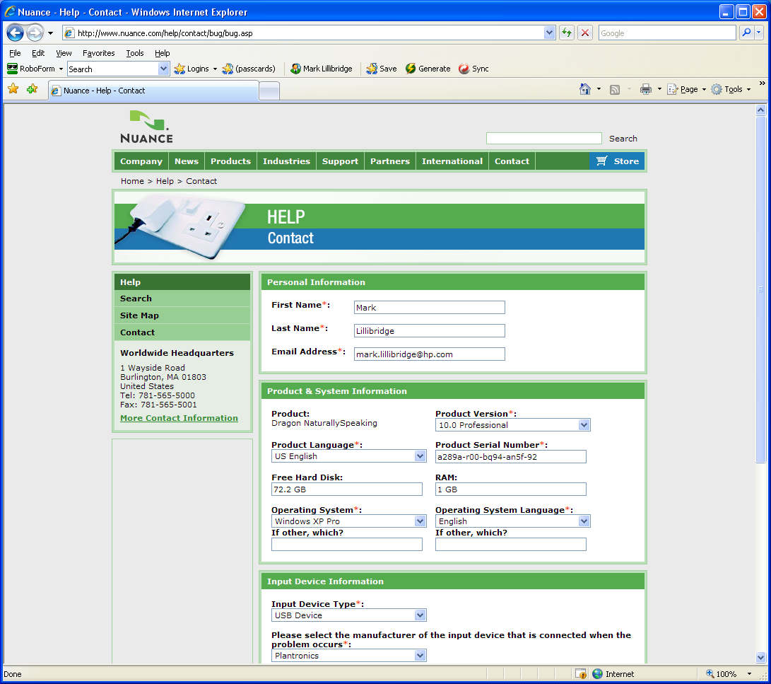
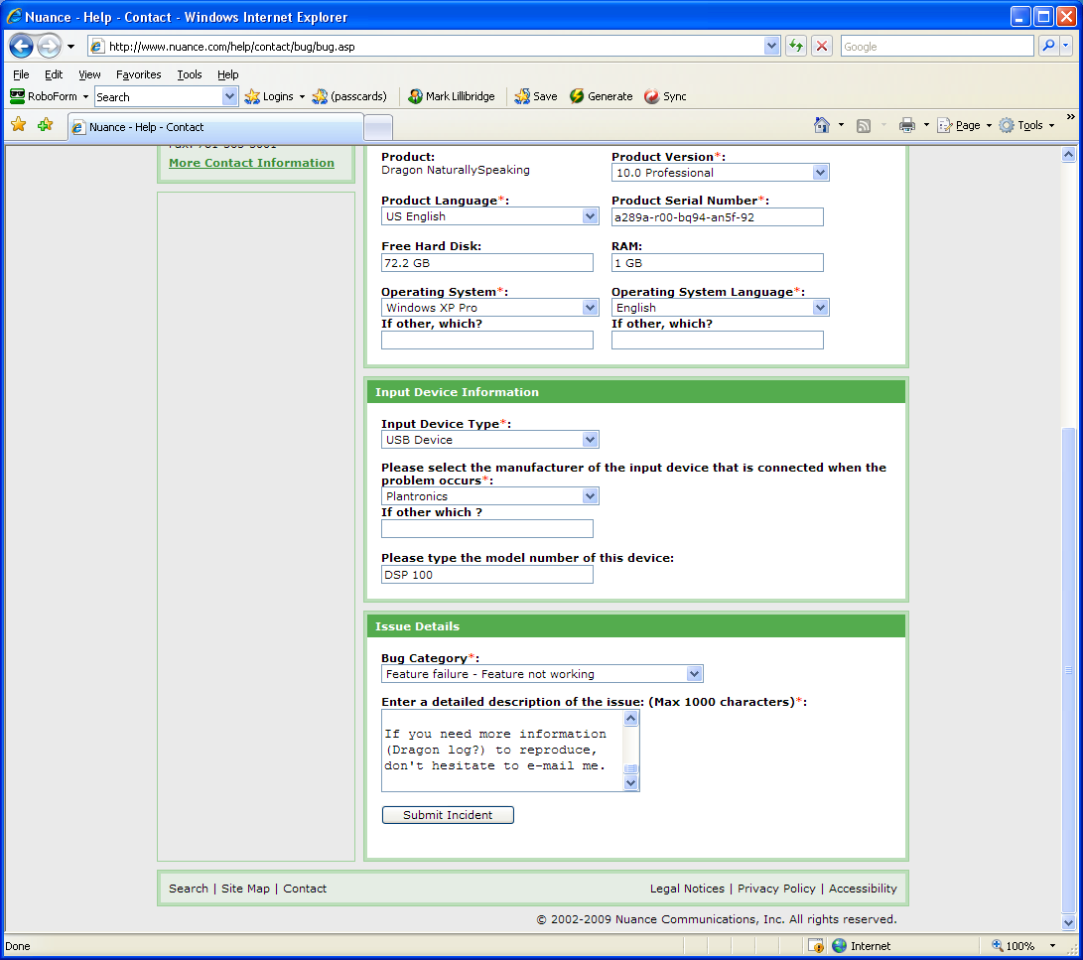
Attempting to correct a phrase dictated using formatting words like 'cap', 'all-caps', or 'Numeral' incorrectly renders the formatting words literally.

Script to reproduce the error:

- open Dragon Pad with an empty file
- dictate “cap read” (Dragon may hear “cap red”; that’s ok), which correctly types “Red”
- dictate “correct that”, which I have set to bring up the correction menu
- choose a correction without ‘cap’ in it via ‘choose <n>’; I usually have ‘Red’ as an option if it originally typed ‘Read’ and vice versa.
- Dragon incorrectly changes the text in the Dragon pad to ‘Cap read’ instead of the chosen ‘Read’. ***BUG***

I see this problem in (all?) applications, not just Dragon pad, under both XP and Vista. This problem occurs with DNS 10.1, but not with DNS 9.5.

If you need more information (Dragon log?) to reproduce, don't hesitate to e-mail me.

